##### **BLOCK CHAIN VOTING SYSTEM**

**A PROJECT REPORT**

###### **Submitted by:**

Naman Mishra (21MIP10007)

Akshat Agrawal (21MIP10022)

Suman Bhandari(21MIP10028)

*in partial fulfillment for the award of the degree*

*of*



**SCHOOL OF COMPUTING SCIENCE AND ENGINEERING**

##### **INTEGRATED MASTER OF TECHNOLOGY**

**COMPUTATIONAL AND DATA SCIENCE**

**VIT BHOPAL UNIVERSITY**

**KOTHRI KALAN, SEHORE**

**MADHYA PRADESH – 466114**

May 2023

**VIT BHOPAL UNIVERSITY, KOTHRI KALAN, SEHORE**

**MADHYA PRADESH – 466114**

**BONAFIDE CERTIFICATE**

Certified that this project report titled **“ BLOCKCHAIN VOTING SYSTEM”** is the bonafide work of “**NAMAN MISHRA (21MIP10007)”** who carried out the project work under my supervision. Certified further that to the best of my knowledge the work reported at this time does not form part of any other project/research work based on which a degree or award was conferred on an earlier occasion on this or any other candidate.

**PROJECT GUIDE Student Name**

Dr. Vairachilai S. Naman Mishra(21MIP10007)

School of Computing

Science and Engineering

VIT BHOPAL UNIVERSITY

**VIT BHOPAL UNIVERSITY, KOTHRI KALAN, SEHORE**

**MADHYA PRADESH – 466114**

**BONAFIDE CERTIFICATE**

Certified that this project report titled **“BLOCKCHAIN VOTING SYSTEM”** is the bonafide work of “**AKSHAT AGRAWAL (21MIP10022)”** who carried out the project work under my supervision. Certified further that to the best of my knowledge the work reported at this time does not form part of any other project/research work based on which a degree or award was conferred on an earlier occasion on this or any other candidate.

**PROGRAM CHAIR STUDENT NAME**

Dr. Vairachilai S. Akshat Agrawal(21MIP10022)

School of Computing

Science and Engineering

VIT BHOPAL UNIVERSITY

**VIT BHOPAL UNIVERSITY, KOTHRI KALAN, SEHORE**

**MADHYA PRADESH – 466114**

**BONAFIDE CERTIFICATE**

Certified that this project report titled **“BLOCKCHAIN VOTING SYSTEM”** is the bonafide work of “**SUMAN BHANDARI (21MIP10028)”** who carried out the project work under my supervision. Certified further that to the best of my knowledge the work reported at this time does not form part of any other project/research work based on which a degree or award was conferred on an earlier occasion on this or any other candidate.

**PROGRAM CHAIR Student Name**

Dr. Vairachilai S. Suman Bhandari(21MIP10028)

School of Computing

Science and Engineering

VIT BHOPAL UNIVERSITY

**ACKNOWLEDGEMENT**

First and foremost, I would like to thank the Lord Almighty for His presence and immense blessings throughout the project work.

Words are indeed inadequate to convey my deep sense of gratitude to our dean Dr. Poonkuntran.S, Dean for inspiring, guiding and encouraging us throughout the project.

I would like to thank Dr. Pon Harshvardhan, Head of the Department, who was actively involved throughout the project and was also kind enough to tell me the strengths and weaknesses and how we could improve ourselves to face the corporate world.

I wish to express my heartfelt gratitude to Dr. Vairachilai, Program Chair, School of Computer Science Engineering for much of her valuable support and encouragement in carrying out this work.

I would like to thank all the technical and teaching staff of the School of Computer Science Engineering, who extended directly or indirectly all support.

Last, but not least, I am deeply indebted to my parents who have been the greatest support while I worked day and night for the project to make it a success.

**TABLE OF CONTENTS**

|  |  |  |
| --- | --- | --- |
| **CHAPTER NO.** | **TITLE** | **PAGE NO.** |
|  | **List of Abbreviations**  **List of Figures and Graphs**  **List of Tables**  **Abstract** |  |
| **1** | **PROJECT DESCRIPTION AND OUTLINE** 1.1 Introduction **1.2 Motivation for the work**  **1.3 Problem Statement**  **1.4 Objective of the work**  **1.5 Organization of the project**  **1.6 Summary** | **14-17** |
| **2** | **RELATED WORK INVESTIGATION**  **2.1 Core area of the project**  **2.2 Existing Approaches/Methods**  **2.2.1 Approaches/Methods -1**  **2.2.2 Approaches/Methods -2** | **18-25** |
| **3** | **REQUIREMENT ARTIFACTS**  **3.1 Introduction**  **3.2 Hardware and Software requirements**  **3.3 Specific Project requirements**  **3.3.1 Data requirement**  **3.3.2 Functions requirement**  **3.3.3 Performance and security requirement** | **26-32** |
| **4** | **DESIGN METHODOLOGY AND ITS NOVELTY**  **4.1 Methodology and goal**  **4.2 Software Architectural designs**  **4.3 Subsystem services**  **4.4 User Interface designs** | **33-40** |
| **5** | **TECHNICAL IMPLEMENTATION & ANALYSIS**  **5.1 Outline**  **5.2 Technical coding and code solutions**  **5.3 Working Layout of Forms**  **5.4 Prototype submission**  **5.5 Test and validation**  **5.6 Performance Analysis**  **5.7 Summary** | **41-46** |
| **6** | **PROJECT OUTCOME AND APPLICABILITY**  **6.2 Significant Project Outcome**  **6.3 Project applicability on Real-world**  **applications** | **46-48** |
| **7** | **CONCLUSIONS AND RECOMMENDATION**  **7.1 Conclusion**  **7.2 Limitation/Constraints of the System**  **7.3 Future Enhancements**  **7. 4 Inference** | **49-53** |
|  | **References** | **54** |

**LIST OF ABBREVIATIONS**

|  |  |
| --- | --- |
| **Abbreviation** | **Full Form** |
| ML | Machine learning |
| pc | Personal Computer |
| UN | United Nation |
| def | define |
| HDD | Hard Disk Drive |
| SSD | Solid State Drive |

|  |  |
| --- | --- |
| **Abbreviation** | **Full Form** |
| Pd | Pandas |
| API | Application Programming Interface |
| GK | General Knowledge |
| CSV | Comma Separated values |
| DAO | Decentralized Autonomous Organization |
| AML | Anti-Money Laundering |

**ABSTRACT**

Online voting is a trend that is gaining momentum in modern society. It has great potential to decrease organizational costs and increase voter turnout. It eliminates the need to print ballot papers or open polling stations—voters can vote from wherever there is an Internet connection. Despite these benefits, online voting solutions are viewed with a great deal of caution because they introduce new threats. A single vulnerability can lead to large-scale manipulations of votes. Electronic voting systems must be legitimate, accurate, safe, and convenient when used for elections. Nonetheless, adoption may be limited by potential problems associated with electronic voting systems. Blockchain technology came into the ground to overcome these issues and offers decentralized nodes for electronic voting and is used to produce electronic voting systems mainly because of their end-to-end verification advantages. This technology is a beautiful replacement for traditional electronic voting solutions with distributed, non-repudiation, and security protection characteristics. The following article gives an overview of electronic voting systems based on blockchain technology.

The main goal of this analysis was to examine the current status of blockchain-based voting research and online voting systems and any related difficulties to predict future developments. This study provides a conceptual description of the intended blockchain-based electronic voting application and an introduction to the fundamental structure and characteristics of the blockchain in connection to electronic voting. As a consequence of this study, it was discovered that blockchain systems may help solve some of the issues that now plague election systems. On the other hand, the most often mentioned issues in blockchain applications are privacy protection and transaction speed. For a sustainable blockchain-based electronic voting system, the security of remote participation must be viable, and for scalability, transaction speed must be addressed. Due to these concerns, it was determined that the existing frameworks need to be improved to be utilized in voting systems.

Blockchain technology has gained significant attention as a potential solution for secure and transparent voting systems. This abstract provides an overview of blockchain-based voting systems, highlighting their key features and benefits.

Traditional voting systems often face challenges related to security, transparency, and trust. Blockchain technology offers a decentralized and tamper-resistant platform for conducting elections. In a blockchain voting system, each vote is recorded as a transaction on a distributed ledger, forming an immutable chain of information. This transparency ensures that all participants can independently verify the integrity of the voting process.

By leveraging cryptographic techniques, blockchain voting systems can protect the privacy and anonymity of voters while ensuring the accuracy of the vote count. Encrypted votes are linked to the previous transactions, making it extremely difficult for malicious actors to alter or manipulate the results. Additionally, blockchain technology provides a robust defense against unauthorized access and tampering, enhancing the overall security of the voting system.

The use of blockchain in voting systems also enables improved accessibility and inclusivity. With remote voting capabilities, individuals with mobility issues or those residing in remote areas can participate in the electoral process. However, it is crucial to address challenges related to digital literacy and ensure equal access to the voting platform for all citizens.

While blockchain voting systems offer promising advantages, there are implementation challenges that need to be overcome. Scalability issues, regulatory considerations, and the need for public acceptance are among the key factors that require careful attention. Pilot projects and experiments are being conducted to test the feasibility and viability of blockchain-based voting systems in real-world scenarios.

Blockchain voting systems have emerged as a potential solution to enhance the transparency, security, and efficiency of elections. By leveraging the decentralized and immutable nature of blockchain technology, these systems aim to revolutionize the way votes are cast, recorded, and counted. In a blockchain voting system, each vote is recorded as a transaction on a distributed ledger, ensuring transparency and eliminating the risk of tampering or fraud. The trust and integrity of the process are strengthened by cryptographic techniques and consensus algorithms employed in the blockchain. Furthermore, blockchain voting systems have the potential to increase accessibility and inclusivity by enabling remote voting and reducing physical barriers. However, challenges related to scalability, privacy, regulatory compliance, and public acceptance must be addressed for widespread adoption. Pilot projects and experiments are being conducted to test the feasibility and effectiveness of blockchain voting systems. While further advancements and refinements are necessary, the potential of blockchain technology to transform the electoral process is promising.

In conclusion, blockchain-based voting systems have the potential to enhance the security, transparency, and integrity of elections. The technology provides a verifiable and resilient platform that can mitigate risks associated with traditional voting systems. Continued research, development, and collaboration are necessary to address the remaining challenges and ensure the successful implementation of blockchain voting systems on a larger scale.

**Chapter - 1**

**PROJECT DESCRIPTION AND OUTLINE**

**INTRODUCTION :**

The traditional methods of conducting elections have long been susceptible to challenges such as fraud, tampering, and lack of transparency. In recent years, blockchain technology has emerged as a potential solution to address these issues and revolutionize the voting process. By leveraging the principles of decentralization, transparency, and immutability, blockchain voting systems offer a new paradigm for secure and efficient elections.

Blockchain, the underlying technology behind cryptocurrencies like Bitcoin, is a decentralized and distributed ledger that records transactions across multiple nodes. Each transaction, in the context of voting, represents an individual vote. These votes are linked together in a chain, forming a transparent and tamper-resistant record of the entire voting process.

One of the key advantages of blockchain voting systems is the transparency they provide. Every participant in the system can access the blockchain and verify the authenticity of each vote. This transparency reduces the chances of fraud and manipulation, as any attempt to alter or tamper with the recorded votes would be immediately evident.

Security is another critical aspect of blockchain voting systems. The decentralized nature of the blockchain ensures that no single entity or authority has control over the voting process. Additionally, the cryptographic techniques employed in blockchain systems, such as encryption and digital signatures, provide robust protection against unauthorized access and tampering.

Moreover, blockchain voting systems have the potential to enhance accessibility and inclusivity. By enabling remote voting through digital platforms, individuals who are unable to physically reach polling stations can still participate in the electoral process. This can benefit people with disabilities, elderly citizens, or those residing in remote areas.

However, the implementation of blockchain voting systems is not without challenges. Scalability remains a concern, as processing a large number of votes on a blockchain can be time-consuming. Ensuring the privacy and anonymity of voters while maintaining the transparency of the system is also a complex task. Additionally, addressing regulatory and legal considerations, such as identity verification and dispute resolution, requires careful attention.

Pilot projects and small-scale experiments have been conducted to test the feasibility and effectiveness of blockchain voting systems. While these systems are still in the experimental stage, they hold the potential to transform the electoral landscape, making it more secure, transparent, and inclusive. Continued research, technological advancements, and collaboration between stakeholders are essential to overcome the challenges and unlock the full potential of blockchain voting systems.

**MOTIVATION :**

The motivation behind exploring blockchain voting systems stems from the need to address inherent challenges and limitations of traditional voting methods. Several key factors drive the motivation for the development and implementation of blockchain technology in the voting process:

Trust and Transparency: Trust is a fundamental requirement for any electoral system. Traditional voting methods often face skepticism due to concerns about the integrity and transparency of the process. Blockchain voting systems provide a solution by leveraging the transparency and immutability of the blockchain. Every vote recorded on the blockchain can be independently verified, enhancing trust in the accuracy and fairness of the results.

Security and Integrity: Ensuring the security and integrity of the voting process is crucial to safeguard the democratic principles. Traditional voting methods are susceptible to various threats, such as hacking, tampering, or fraudulent activities. Blockchain voting systems offer robust security measures through cryptographic techniques and decentralization. The decentralized nature of the blockchain eliminates the risk of a single point of failure, making it extremely difficult for malicious actors to manipulate or alter the voting data.

Efficiency and Cost Savings: Traditional voting systems often involve significant administrative efforts, paperwork, and logistical challenges. Counting and verifying votes can be time-consuming and resource-intensive. Implementing blockchain voting systems streamlines the process, automating many tasks and reducing the need for intermediaries. This improves the overall efficiency and can potentially result in cost savings for election organizers.

Accessibility and Inclusivity: Blockchain voting systems have the potential to address barriers to participation and improve accessibility for a broader range of voters. By enabling remote voting through digital platforms, individuals who face challenges in physically attending polling stations, such as those with disabilities or living in remote areas, can exercise their voting rights. This promotes inclusivity and ensures that every eligible citizen has an opportunity to participate in the democratic process.

Voter Confidence and Engagement: Public trust in the electoral system is crucial for the legitimacy of elected representatives and the overall democratic process. By incorporating blockchain technology, which is perceived as secure and transparent, blockchain voting systems can help boost voter confidence. Increased trust in the voting process can lead to higher voter turnout and greater engagement in democratic decision-making.

Innovation and Future-Proofing: Embracing blockchain voting systems represents an opportunity to leverage cutting-edge technology and promote innovation in the electoral field. As blockchain technology continues to evolve, new features and improvements can be integrated into the voting systems, ensuring their resilience and adaptability to future challenges.

The motivation behind blockchain voting systems lies in addressing the limitations of traditional voting methods and harnessing the potential of blockchain technology to create a more secure, transparent, and inclusive electoral process. While there are challenges to overcome, the potential benefits and the pursuit of a more robust democracy continue

**PROBLEM STATEMENT :**

Traditional voting systems lack transparency, security, scalability, privacy, and face regulatory challenges. Trust in the accuracy of results is compromised due to limited transparency. Security vulnerabilities expose the voting process to tampering and fraud. Scalability issues hinder efficient processing of a large volume of votes. Preserving voter privacy while ensuring transparency is a challenge. Additionally, regulatory and legal considerations must be addressed for the adoption of blockchain voting systems. Overcoming these problems is crucial to develop a secure, transparent, scalable, and legally compliant blockchain voting system.

**ORGANIZATION OF WORK :**

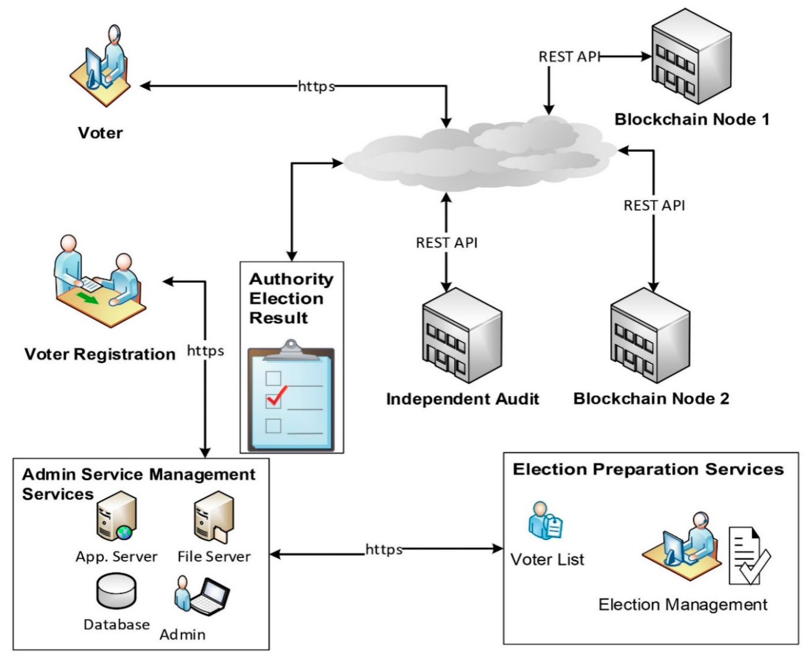

**SUMMARY :**

In summary, blockchain voting systems aim to revolutionize the traditional voting process by leveraging the transparency, security, and decentralization of blockchain technology. The objectives of implementing a blockchain voting system include enhancing transparency, improving security and integrity, increasing accessibility and inclusivity, ensuring privacy and confidentiality, enhancing efficiency and cost-effectiveness, and fostering trust and voter confidence. By addressing the limitations of traditional voting methods and leveraging the unique features of blockchain, these systems strive to create a more trustworthy, inclusive, and efficient electoral process.

**CHAPTER - 2**

**RELATED WORK INVESTIGATION**

**CORE AREA OF THE PROJECT :**

pragma solidity ^0.4.24;

contract Voting {

// Candidate structure

struct Candidate {

uint id;

string name;

uint voteCount;

}

// Store accounts that have voted

mapping(address => bool) public voters;

// Store Candidates

mapping(uint => Candidate) public candidates;

// Store Candidates Count

uint public candidatesCount;

// Constructor

constructor() public {

addCandidate("Candidate 1");

addCandidate("Candidate 2");

}

// Add candidate function

function addCandidate(string memory _name) private {

candidatesCount++;

candidates[candidatesCount] = Candidate(candidatesCount, _name, 0);

}

// Vote function

function vote(uint _candidateId) public {

// Require that the voter hasn't voted before

require(!voters[msg.sender]);

// Require a valid candidate

require(_candidateId > 0 && _candidateId <= candidatesCount);

// Record that voter has voted

voters[msg.sender] = true;

// Update candidate vote count

candidates[_candidateId].voteCount++;

}

}

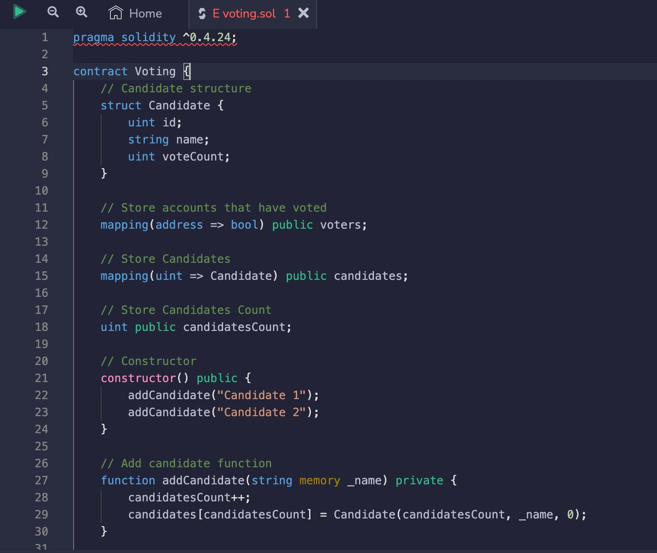

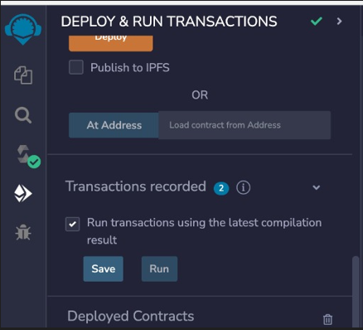

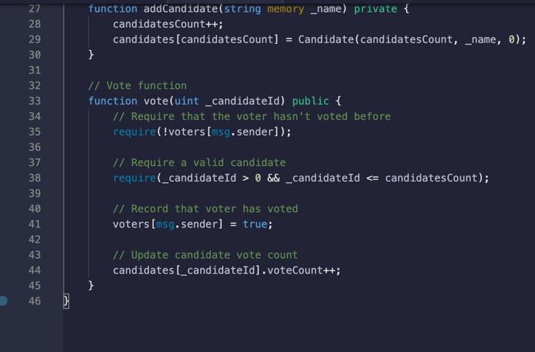

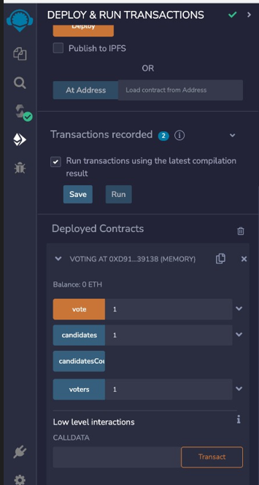

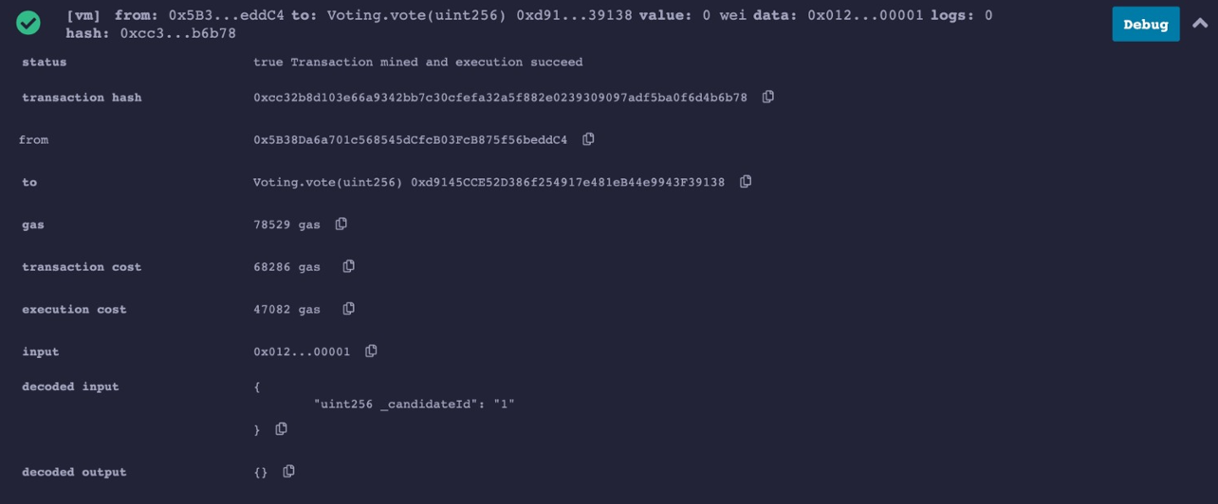

**CHAPTER-3:**

**REQUIREMENT ARTIFACTS**

**INTRODUCTION:**

The traditional methods of conducting elections have long been susceptible to challenges such as fraud, tampering, and lack of transparency. In recent years, blockchain technology has emerged as a potential solution to address these issues and revolutionize the voting process. By leveraging the principles of decentralization, transparency, and immutability, blockchain voting systems offer a new paradigm for secure and efficient elections.

Blockchain, the underlying technology behind cryptocurrencies like Bitcoin, is a decentralized and distributed ledger that records transactions across multiple nodes. Each transaction, in the context of voting, represents an individual vote. These votes are linked together in a chain, forming a transparent and tamper-resistant record of the entire voting process.

One of the key advantages of blockchain voting systems is the transparency they provide. Every participant in the system can access the blockchain and verify the authenticity of each vote. This transparency reduces the chances of fraud and manipulation, as any attempt to alter or tamper with the recorded votes would be immediately evident.

Security is another critical aspect of blockchain voting systems. The decentralized nature of the blockchain ensures that no single entity or authority has control over the voting process. Additionally, the cryptographic techniques employed in blockchain systems, such as encryption and digital signatures, provide robust protection against unauthorized access and tampering.

Moreover, blockchain voting systems have the potential to enhance accessibility and inclusivity. By enabling remote voting through digital platforms, individuals who are unable to physically reach polling stations can still participate in the electoral process. This can benefit people with disabilities, elderly citizens, or those residing in remote areas.

However, the implementation of blockchain voting systems is not without challenges. Scalability remains a concern, as processing a large number of votes on a blockchain can be time-consuming. Ensuring the privacy and anonymity of voters while maintaining the transparency of the system is also a complex task. Additionally, addressing regulatory and legal considerations, such as identity verification and dispute resolution, requires careful attention.

Pilot projects and small-scale experiments have been conducted to test the feasibility and effectiveness of blockchain voting systems. While these systems are still in the experimental stage, they hold the potential to transform the electoral landscape, making it more secure, transparent, and inclusive. Continued research, technological advancements, and collaboration between stakeholders are essential to overcome the challenges and unlock the full potential of blockchain voting systems.

**HARDWARE AND SOFTWARE REQUIREMENTS:**

**Software:**

* MetaMask Wallet
* Ganache
* Remix IDE
* Solidity

**Hardware:**

* Processor = 1 gigahertz (GHz) or faster processor
* Storage Space = 1 GB
* RAM 2GB DDR4
* Hard Disk - Any (HDD or SSD)
* Graphic card - Integrated 2gb 64 bit
* Servers or Nodes
* Network Infrastructure

**FUNCTION REQUIREMENTS :**

Function requirements for a blockchain voting system implemented in Solidity, a programming language commonly used for Ethereum smart contracts, may include:

**registerVoter**: Registers a voter in the system, ensuring they meet the eligibility criteria. This function may require parameters such as the voter's identification information and verification process.

**castVote**: Allows a registered voter to cast their vote for a particular candidate or ballot option. This function may require parameters such as the voter's identification and the chosen candidate or option.

**getVoteCount**: Retrieves the total number of votes cast for a specific candidate or option. This function may return the count as an integer.

**getWinner**: Determines and returns the winning candidate or option based on the vote counts. This function may utilize algorithms such as simple majority or plurality.

**endVoting**: Ends the voting process, preventing any further votes from being cast. This function may require appropriate authorization or time restrictions.

**getVoterStatus**: Retrieves the voting status of a particular voter. This function may return information indicating whether the voter has already cast their vote.

**getVoterCount**: Retrieves the total number of registered voters. This function may return the count as an integer.

**getVoterInfo**: Retrieves the information and status of a specific voter. This function may require the voter's identification and return relevant voter details.

**verifyVote**: Verifies the integrity and authenticity of a specific vote. This function may require the vote ID or other identifying parameters and return a verification result.

**getContractBalance**: Retrieves the balance of the smart contract's address. This function may be useful for monitoring and managing contract funds or incentives.

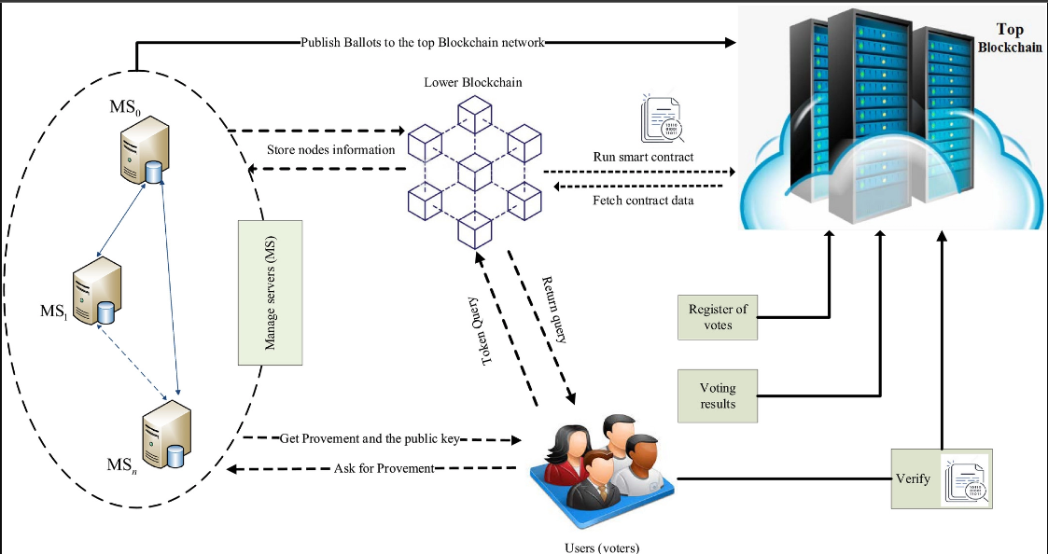

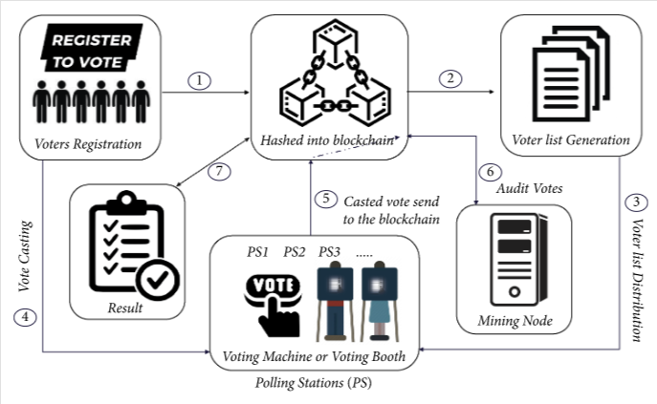

**DATA REQUIREMENTS :**

In a blockchain voting system, there are several data requirements to ensure the integrity, security, and transparency of the voting process. Here are some key data requirements:

**Voter Registration Data:** This includes information about eligible voters, such as their names, unique identifiers, addresses, and any other necessary identification details. This data is used to verify the eligibility of voters and prevent duplicate voting.

**Ballot Data:** Ballot data contains the list of candidates or options available for voting. Each candidate or option is associated with a unique identifier. This data is used to create the ballots and record the choices made by the voters.

**Vote Data:** Vote data includes the individual votes cast by each voter. It typically consists of the unique identifier of the voter, the unique identifier of the chosen candidate or option, and any additional cryptographic information required for verification and validation.

**Timestamps:** Each action in the blockchain voting system should be recorded with a timestamp to ensure the chronological order of events. Timestamps are crucial for auditing and detecting any irregularities or tampering attempts.

**Blockchain Transactions**: All interactions within the blockchain voting system, including voter registration, ballot creation, vote submission, and result calculation, should be recorded as blockchain transactions. These transactions are used to create an immutable and transparent audit trail.

**Digital Signatures:** Digital signatures are used to verify the authenticity and integrity of the data. Each vote and transaction should be signed by the respective participants to ensure that the data has not been tampered with.

**Public Key Infrastructure (PKI) Data:** PKI data includes the cryptographic keys used for encryption, decryption, and digital signatures within the blockchain voting system. This data is necessary to establish secure communication channels and validate the authenticity of participants.

**Results Data**: Once the voting process is completed, the results data should be generated. It includes the aggregated vote counts for each candidate or option, along with any other relevant information, such as voter turnout and statistical analysis.

It is important to note that privacy is a critical consideration in a blockchain voting system. While the system requires certain data to ensure the integrity of the process, it should also protect the confidentiality of individual votes to maintain voter anonymity. Various privacy-enhancing techniques, such as zero-knowledge proofs and homomorphic encryption, can be employed to achieve this balance.

**PERFORMANCE REQUIREMENTS IN A BLOCKCHAIN VOTING SYSTEM:**

**Throughput:** The system should be able to handle a high volume of transactions efficiently to accommodate a large number of voters and prevent delays or congestion.

**Scalability:** The system should be designed to scale horizontally or vertically to handle an increasing number of participants and transactions without sacrificing performance.

**Latency:** The time taken to process and confirm a transaction should be minimized to ensure a smooth and timely voting experience.

**Response Time:** The system should respond to user interactions promptly, providing real-time updates on the status of the voting process and any necessary notifications.

**Network Efficiency**: The system should optimize network utilization to minimize bandwidth requirements and ensure fast and reliable communication between nodes.

**SECURITY REQUIREMENTS IN A BLOCKCHAIN VOTING SYSTEM:**

**Immutable and Tamper-Resistant:** The blockchain should be designed to ensure that once a transaction is recorded, it cannot be modified or tampered with, maintaining the integrity of the voting process.

**Data Confidentiality:** Voter anonymity should be protected, ensuring that individual votes cannot be traced back to specific voters.

**Authentication and Authorization:** The system should implement robust mechanisms to authenticate voters and prevent unauthorized access or manipulation of voting data.

**Encryption:** Sensitive data, such as voter registration information and cryptographic keys, should be encrypted to protect it from unauthorized access.

**Anti-Spoofing Measures:** The system should incorporate measures to detect and prevent spoofing attacks, such as impersonation or falsification of identities.

**Distributed Consensus:** The consensus algorithm used in the blockchain should be secure and resilient against attacks, ensuring that the majority of the network agrees on the validity of transactions.

**Redundancy and Fault Tolerance:** The system should be designed to withstand failures, ensuring that critical data is replicated and accessible even in the presence of network or node failures.

**Auditability and Transparency:** The blockchain should provide a transparent and auditable record of all transactions, allowing for the verification and validation of the voting process by independent parties.

**Disaster Recovery:** Mechanisms should be in place to backup and restore the blockchain data in case of catastrophic events or data loss.

**CHAPTER-4:**

**DESIGN METHODOLOGY AND ITS NOVELTY**

In this study, we followed the proposed systematic mapping method presented in Petersen et al.  shows the mapping method workflow and all the process steps that have been implemented. The process initially includes the definition of research questions. Secondly, an extensive search of publications has been carried out followed by the identification of relevant sources according to criteria. Finally, the studies have been analyzed and classified while synthesizing and summarizing the information extracted.

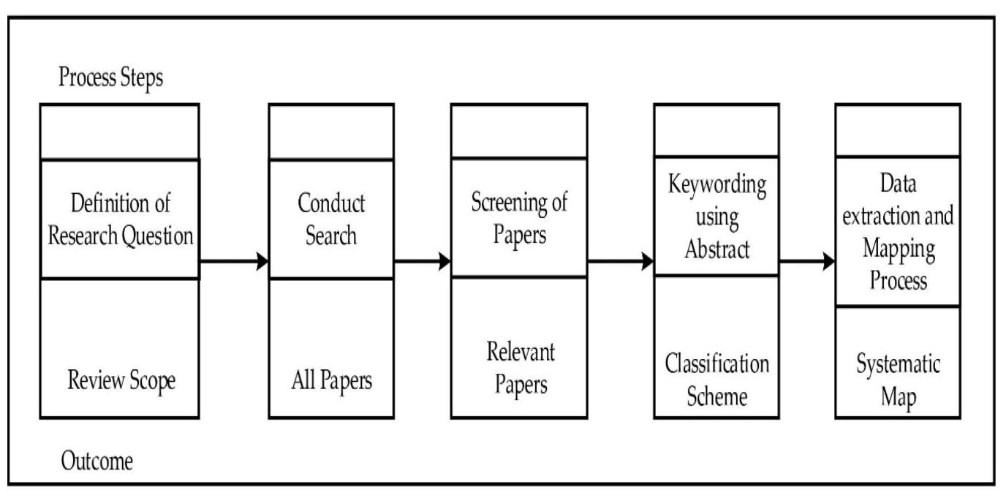

The Systematic Mapping Process

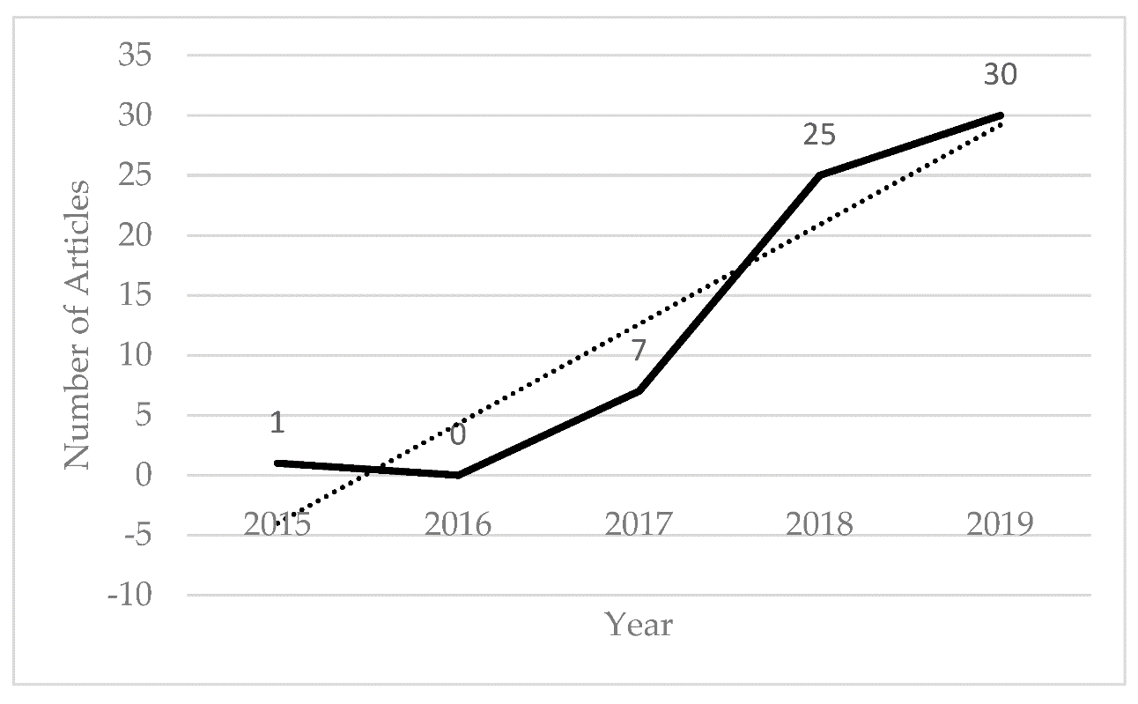

**Software Architectural designs**

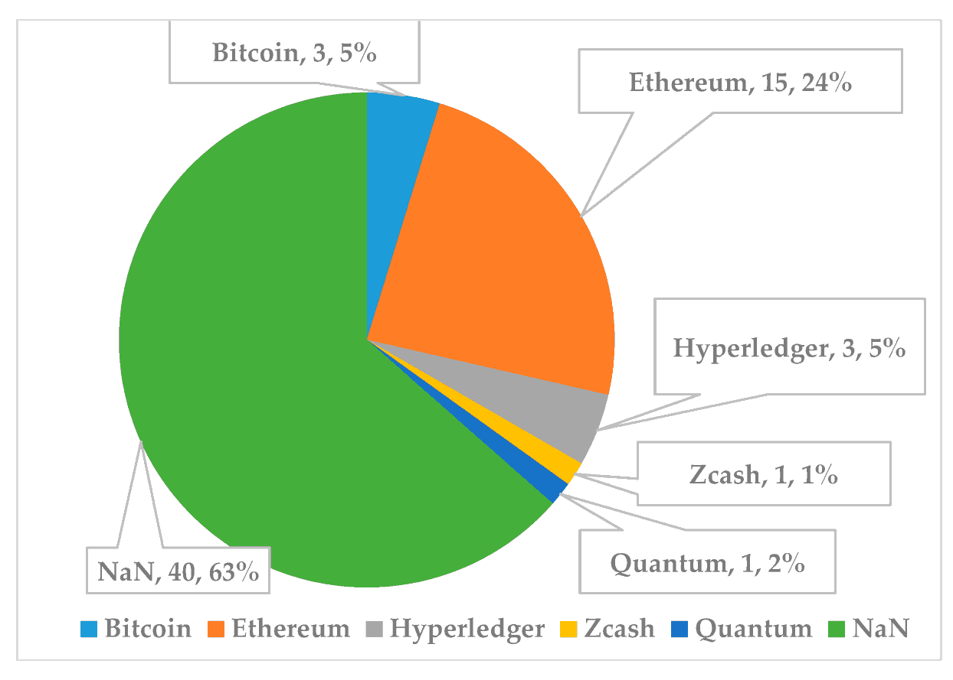

**SUBSYSTEM SERVICES:**

In a blockchain voting system, various subsystem services work together to provide the necessary functionalities. Here are some common subsystem services found in a blockchain voting system:

**Voter Registration Service:**

This service handles the registration of eligible voters. It verifies the identity and eligibility of voters, collects and stores their registration data, and assigns unique identifiers. It ensures that each voter is registered only once and maintains the integrity and security of the voter registration process.

**Ballot Generation Service:**

The ballot generation service creates the ballots for each voting event. It retrieves the list of candidates or options from a secure source, generates unique identifiers for each option, and structures the ballots for distribution. This service ensures that the ballot data is accurately represented and securely generated.

**Vote Casting Service:**

The vote casting service enables voters to cast their votes securely. It provides interfaces for voters to select their preferred candidates or options, encrypts the votes, and securely transmits them to the blockchain network. This service ensures that votes are accurately captured, protected from tampering, and securely recorded on the blockchain.

**Consensus Service:**

The consensus service is responsible for validating and confirming the transactions (votes) to be added to the blockchain. It implements the chosen consensus algorithm, such as Proof of Work (PoW) or Proof of Stake (PoS), to achieve agreement among the network participants on the validity of the votes. The consensus service ensures the integrity and immutability of the blockchain.

**Verification Service:**

The verification service checks the validity and authenticity of votes and transactions. It verifies digital signatures, checks for duplicate votes or tampering attempts, and ensures that the votes adhere to the predefined voting rules. This service plays a crucial role in maintaining the integrity and security of the voting process.

**Results Calculation Service:**

The results calculation service aggregates the votes recorded on the blockchain to determine the outcome of the voting process. It tallies the votes, applies any necessary algorithms or rules for calculating results (e.g., plurality, majority), and generates the final results. This service ensures accuracy, transparency, and efficiency in determining the election outcomes.

**Audit and Monitoring Service:**

The audit and monitoring service provides tools and functionalities for auditing and monitoring the blockchain voting system. It allows independent observers to verify the integrity of the system, track any suspicious activities, and perform post-election audits. This service contributes to the transparency and trustworthiness of the voting process.

**Reporting and Analytics Service:**

The reporting and analytics service generates reports and analytics based on the voting data. It can provide statistical analysis, visualization of results, and insights into voter demographics and trends. This service supports decision-making and enhances transparency in the electoral process.

**Security Service:**

The security service encompasses various measures to protect the blockchain voting system. It includes encryption mechanisms, access controls, intrusion detection systems, and other security protocols to safeguard the system from unauthorized access, tampering, or data breaches.

**Integration Service:**

The integration service facilitates the integration of the blockchain voting system with external systems and services. It enables communication with voter registration databases, identity verification services, election authorities, and other relevant entities. This service ensures seamless data exchange and interoperability with external systems.

These subsystem services work together to provide a secure, transparent, and efficient blockchain voting system. The specific services and their functionalities may vary depending on the design and requirements of the system.

**USER INTERFACE DESIGNS :**

The user interface (UI) designs of a blockchain voting system can vary depending on the specific implementation and requirements. However, here are some common UI elements and designs that are often utilized in blockchain voting systems:

**Voter Registration Interface:**

The registration interface typically includes input fields for voters to provide their personal information, such as name, address, and identification details. It may also include features like validation checks, password creation, and confirmation steps to ensure accurate and secure registration.

**Ballot Interface:**

The ballot interface presents the list of candidates or options available for voting. It can be designed as a clear and organized list, displaying candidate names, photos, and brief descriptions. The interface may include visual cues, such as checkboxes or radio buttons, to allow voters to select their preferred choices easily.

**Vote Confirmation and Review:**

After making their selections, voters are usually presented with a summary of their choices for review. The interface should provide a clear confirmation button for users to submit their votes. It may also include an option to go back and make any necessary changes before finalizing the vote.

**Authentication and Security:**

To ensure secure access to the voting system, the UI should provide authentication features, such as login screens or biometric authentication (e.g., fingerprint or facial recognition). Security indicators, such as SSL certificates or lock icons, can be displayed to reassure users about the secure transmission of their data.

**Accessibility Considerations:**

UI designs should prioritize accessibility to accommodate users with different abilities. This includes providing alternative text for images, using clear and readable fonts, ensuring sufficient color contrast, and allowing keyboard navigation for users who rely on assistive technologies.

**Real-time Updates and Notifications:**

During the voting process, the UI can incorporate real-time updates to keep voters informed. For example, displaying notifications when votes are successfully submitted or showing progress indicators to indicate the status of the overall voting process.

**Results Display:**

After the voting period concludes, the UI may present the results in an easy-to-understand format. This can include displaying vote counts for each candidate or option, visual representations such as charts or graphs, and any additional analysis or breakdowns of the voting data.

**Help and Support:**

Including a dedicated help section or FAQ within the UI can provide voters with assistance and answers to common questions. Contact information or support channels should be easily accessible for users to seek help or report any issues they encounter.

**Mobile Responsiveness:**

As many users may prefer to vote using mobile devices, the UI should be responsive and optimized for various screen sizes. This ensures that the voting experience remains consistent and user-friendly across different devices.

**Privacy and Data Protection:**

The UI should address privacy concerns by clearly communicating how user data is handled and protected. It should provide options for users to manage their privacy settings and offer transparency about data collection, storage, and processing practices.

These UI designs should align with the principles of simplicity, intuitiveness, and visual clarity to enhance user experience and encourage participation in the blockchain voting system.

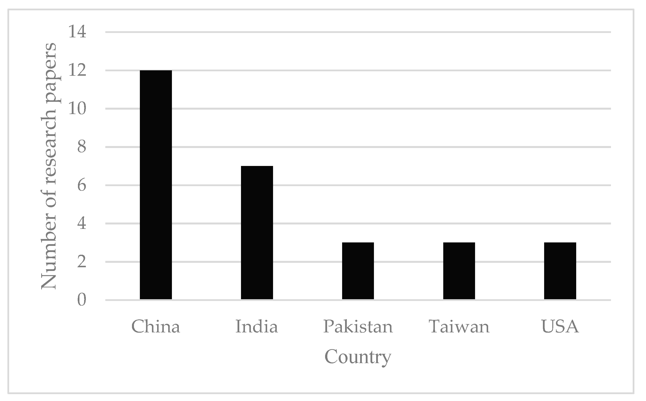

Journal article and proceedings papers on the blockchain voting system in the top 5 countries.

**CHAPTER 5**

**TECHNICAL IMPLEMENTATION & ANALYSIS**

A blockchain voting system is a transparent and secure platform for conducting elections. It utilizes blockchain technology and smart contracts to ensure the integrity of the voting process. The system includes features such as secure voter registration, encrypted ballot creation, and distribution to eligible voters. Votes are recorded on the blockchain, making them immutable and tamper-proof. Security measures like encryption protocols and digital signatures protect voter identities and ensure data integrity. The system provides a user-friendly interface for voter participation, promoting transparency, and trust in the electoral process.

**Technical coding and code solutions :**

Use programming languages like Solidity (for Ethereum) or Chaincode (for Hyperledger Fabric) to write smart contracts that govern the voting process. Smart contracts define the rules, logic, and interactions within the system. Utilize blockchain platforms such as Ethereum, Hyperledger Fabric, or others to create and deploy the blockchain network for recording and validating voting transactions.

Code :

pragma solidity ^0.4.24;

contract Voting {

// Candidate structure

struct Candidate {

uint id;

string name;

uint voteCount;

}

// Store accounts that have voted

mapping(address => bool) public voters;

// Store Candidates

mapping(uint => Candidate) public candidates;

// Store Candidates Count

uint public candidatesCount;

// Constructor

constructor() public {

addCandidate("Candidate 1");

addCandidate("Candidate 2");

}

// Add candidate function

function addCandidate(string memory _name) private {

candidatesCount++;

candidates[candidatesCount] = Candidate(candidatesCount, _name, 0);

}

// Vote function

function vote(uint _candidateId) public {

// Require that the voter hasn't voted before

require(!voters[msg.sender]);

// Require a valid candidate

require(_candidateId > 0 && _candidateId <= candidatesCount);

// Record that voter has voted

voters[msg.sender] = true;

// Update candidate vote count

candidates[_candidateId].voteCount++;

}

}



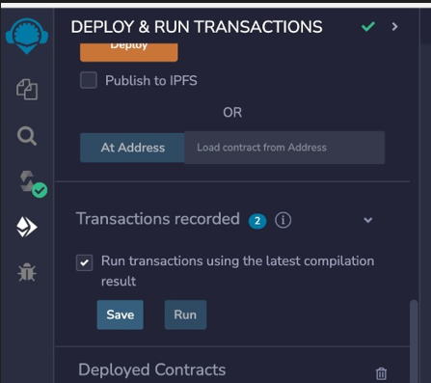

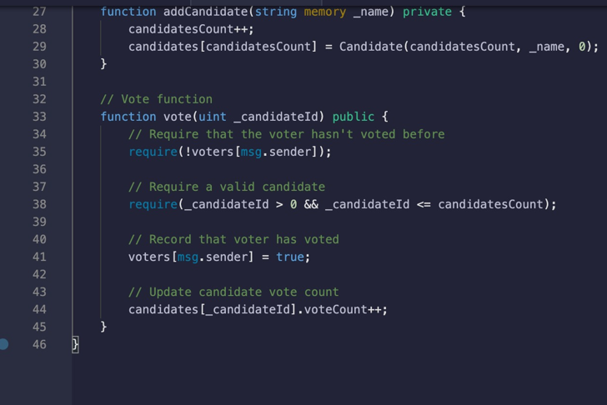

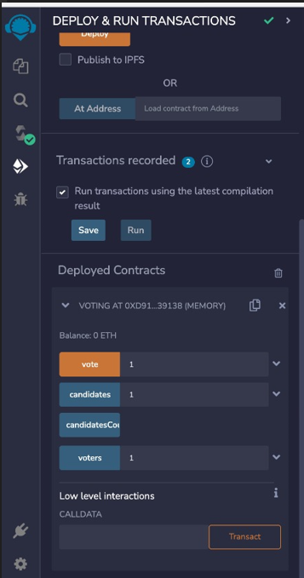

OUTPUT :

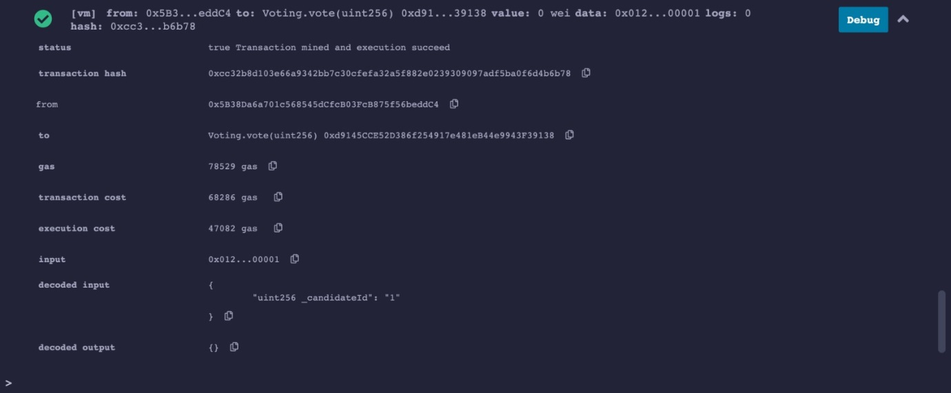

**CHAPTER 6**

**PROJECT OUTCOME AND APPLICABILITY**

**SIGNIFICANT PROJECT OUTCOMES :**

Blockchain-based voting systems have shown promising outcomes, including enhanced transparency, improved security, and increased accessibility. These systems leverage the immutability and transparency of the blockchain to provide auditable and verifiable voting processes. By employing cryptographic techniques and decentralized consensus mechanisms, they aim to protect against manipulation and unauthorized access to votes, ensuring the integrity of the voting process. Additionally, blockchain voting systems can enable remote voting, making it more convenient for voters and potentially increasing voter participation. While further research and development are needed, these outcomes highlight the potential of blockchain technology to revolutionize the voting landscape.

**REAL WORLD EXAMPLES :**

There have been several real-world examples and pilot projects exploring the use of blockchain in voting systems. Here are a few notable examples:

**West Virginia, USA:**

In 2018, West Virginia became the first state in the United States to implement a blockchain-based voting system for the primary elections. The system allowed military personnel stationed overseas to vote using a mobile application called Voatz. The goal was to improve accessibility and security for remote voters.

**Moscow City, Russia:**

Moscow City conducted a pilot project in 2019, using blockchain technology for an electronic voting system. The system aimed to enhance transparency and enable voters to verify that their votes were correctly counted and recorded. It utilized the Ethereum blockchain and smart contracts to ensure the integrity of the voting process.

**Sierra Leone:**

In 2018, Sierra Leone partnered with a Swiss blockchain company called Agora to pilot a blockchain-based voting system during the country's presidential elections. The project aimed to provide a transparent and tamper-proof method for tallying votes and increasing public trust in the election results.

**Tsukuba City, Japan:**

Tsukuba City in Japan conducted a trial of a blockchain-based voting system in 2019. The system allowed residents to vote on local social contribution projects using their smartphones. The blockchain technology ensured the security and transparency of the voting process.

**South Korea:**

South Korea has been exploring the use of blockchain in various sectors, including voting. In 2020, the country's National Election Commission conducted a successful pilot project for remote voting using blockchain technology. The project aimed to enhance voter convenience and increase trust in the electoral process.

These examples highlight how blockchain technology is being experimented with and tested in real-world voting scenarios. While the technology holds promise, it is important to consider the challenges and potential risks associated with implementing blockchain voting systems, including scalability, privacy, and regulatory considerations.

**CHAPTER 7**

**CONCLUSIONS AND RECOMMENDATION**

**CONCLUSION :**

In conclusion, blockchain voting systems have the potential to revolutionize the way we conduct elections. By leveraging the decentralized and transparent nature of blockchain technology, these systems offer enhanced transparency, improved security, and increased accessibility. The immutability of the blockchain ensures the integrity of votes, protecting against tampering and manipulation. Through cryptographic techniques and decentralized consensus mechanisms, blockchain voting systems can provide a trusted and auditable platform for democratic processes. However, challenges such as scalability, privacy concerns, and regulatory considerations must be addressed for widespread adoption. With further research, development, and careful implementation, blockchain voting systems hold promise in promoting trust, inclusivity, and integrity in elections.

**LIMITATION/CONSTRAINTS OF THE SYSTEM :**

While blockchain voting systems offer various advantages, they also have limitations and constraints that need to be considered:

**Technical Complexity:** Implementing a blockchain voting system requires specialized technical knowledge in blockchain development, cryptography, and secure coding practices. The complexity of the technology can present challenges in terms of development, integration, and maintenance.

**Scalability:** Blockchain networks, especially public ones, can face scalability issues. As the number of participants and transactions increases, the system's performance and transaction processing speed can be adversely affected. Ensuring that the blockchain voting system can handle a large number of voters simultaneously is a significant challenge.

**Privacy Concerns:** While blockchain technology offers transparency, it can raise privacy concerns when it comes to voting. Balancing the need for transparency with voter anonymity and data protection is a challenge. Special care must be taken to ensure that voter identities and choices are adequately protected.

**Governance and Regulation:** Implementing blockchain voting systems involves legal and regulatory considerations. Adapting existing election laws and regulations to accommodate this new technology can be complex. Developing a governance framework to address disputes, fraud prevention, and ensuring compliance with regulations is crucial.

**User Adoption and Accessibility:** Ensuring user adoption and accessibility of the blockchain voting system can be challenging. Not all voters may be familiar with the technology, and providing user-friendly interfaces and clear instructions is essential. Accessibility for individuals with disabilities or limited access to technology should also be considered.

**Network Security Risks:** While blockchain technology is considered secure, there are still potential risks related to network attacks, vulnerabilities in smart contracts, or compromised endpoints. Robust security measures and continuous monitoring are necessary to mitigate these risks.

**Trust and Perception:** Gaining public trust and confidence in blockchain voting systems can be a significant challenge. Educating the public about the technology, addressing concerns regarding its reliability and security, and conducting thorough audits and transparency measures are essential for building trust.

It is important to carefully address these limitations and constraints through rigorous testing, collaboration with experts, and continuous improvement to ensure the reliability, security, and usability of blockchain voting systems.

**FUTURE ENHANCEMENTS:**

Future enhancements for blockchain voting systems can focus on addressing the limitations and constraints to further improve their effectiveness. These enhancements could include advancements in scalability solutions, such as sharding or layer-two protocols, to accommodate a larger number of voters and transactions. Research into privacy-preserving techniques like zero-knowledge proofs can provide stronger anonymity protections while maintaining the transparency of the voting process. Integration with emerging technologies like secure hardware or biometric authentication can enhance voter identity verification. Additionally, exploring interoperability between different blockchain networks and collaboration with regulatory bodies can help establish standardized governance frameworks, paving the way for broader adoption and acceptance of blockchain voting systems.

**INFERENCE:**

The inference of a blockchain voting system is that it has the potential to revolutionize the electoral process by providing transparency, security, and accessibility. By leveraging the decentralized and tamper-proof nature of blockchain technology, these systems can enhance trust and confidence in elections. The use of cryptographic techniques ensures the integrity and confidentiality of votes, while the transparency of the blockchain allows for auditing and verification. Blockchain voting systems also offer the opportunity for remote voting, increasing participation and inclusivity. However, challenges such as technical complexity, scalability, privacy concerns, and regulatory considerations need to be addressed for widespread adoption. With further development and refinement, blockchain voting systems can play a significant role in promoting democratic processes worldwide.

**REFERENCES**

1. <https://www.mdpi.com/1424-8220/21/17/5874>
2. <https://core.ac.uk/download/pdf/155779036.pdf>
3. <https://www.hindawi.com/journals/sp/2022/1383007/>
4. <https://www.researchgate.net/profile/Andrea-Pinna-6/publication/327907758_Crypto-voting_a_Blockchain_based_e-Voting_System/links/5cb8de2da6fdcc1d499ef07a/Crypto-voting-a-Blockchain-based-e-Voting-System.pdf>
5. <https://www.researchgate.net/profile/Hansarandi-Adithya/publication/368282306_Electronic_Voting_System_based_on_Blockchain_for_Sri_Lanka_Conceptual_Overview/links/63df4a1ac97bd76a826c3b60/Electronic-Voting-System-based-on-Blockchain-for-Sri-Lanka-Conceptual-Overview.pdf>
6. <https://ieeexplore.ieee.org/abstract/document/9787540>
7. <https://www.mdpi.com/article/10.3390/app13021096>
8. h[ttps://www.researchgate.net/profile/Andrea-Pinna-6/publication/327907758_Crypto-voting_a_Blockchain_based_e-Voting_System/links/5cb8de2da6fdcc1d499ef07a/Crypto-voting-a-Blockchain-based-e-Voting-System.pdf](https://www.researchgate.net/profile/Andrea-Pinna-6/publication/327907758_Crypto-voting_a_Blockchain_based_e-Voting_System/links/5cb8de2da6fdcc1d499ef07a/Crypto-voting-a-Blockchain-based-e-Voting-System.pdf)
9. https://ietresearch.onlinelibrary.wiley.com/share/GXGDRTEDCKZCT7D4N55V?target=10.1049/blc2.12021